Sphere
# Source: AI Source: Provided by: [Data Path: Persons Table -> ID Column: 1, Name_En Column: Motasem Essam] -> From: [ChatGPT] on [7/25/2026]
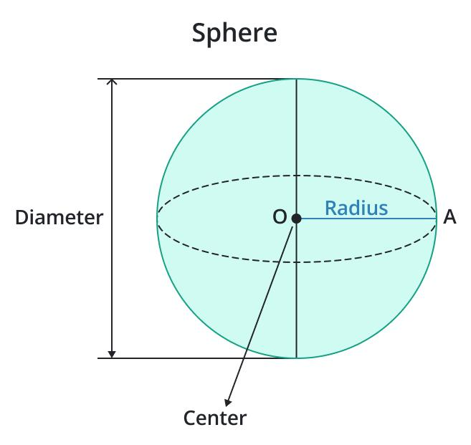
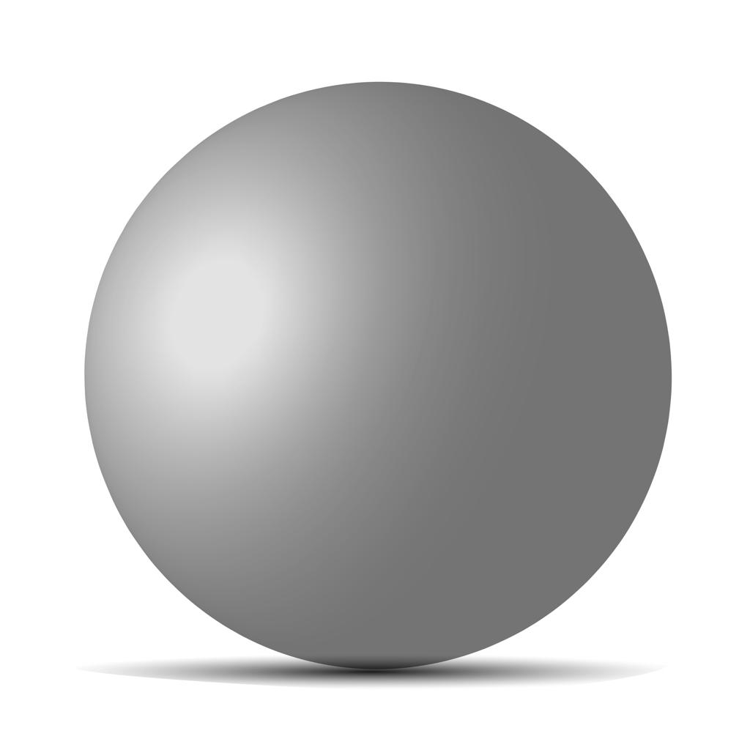
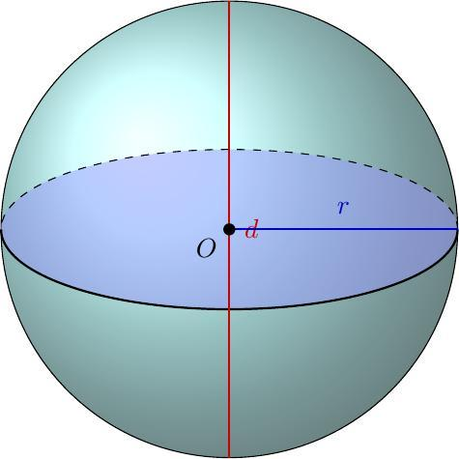

Definition
# Source: AI Source: Provided by: [Data Path: Persons Table -> ID Column: 1, Name_En Column: Motasem Essam] -> From: [ChatGPT] on [7/25/2026]
A sphere is a three-dimensional geometric solid consisting of all points in space that are at a distance less than or equal to a fixed distance $r$ from a fixed point $O$, called the center.
In common geometry terminology, the surface of a sphere is the set of points exactly distance $r$ from the center, while the solid sphere includes both the surface and its interior.
A sphere has a completely curved boundary, with no flat faces, straight edges, or vertices.

Simple Definition
# Source: AI Source: Provided by: [Data Path: Persons Table -> ID Column: 1, Name_En Column: Motasem Essam] -> From: [ChatGPT] on [7/25/2026]
A sphere is a round three-dimensional solid whose surface points are all equally distant from its center.
Examples include an idealized ball, a spherical bead, and a globe modeled as a perfect sphere.

Key Characteristics
# Source: AI Source: Provided by: [Data Path: Persons Table -> ID Column: 1, Name_En Column: Motasem Essam] -> From: [ChatGPT] on [7/25/2026]
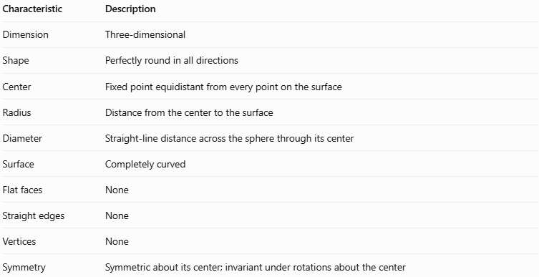
Characteristic | Description
Dimension | Three-dimensional
Shape | Perfectly round in all directions
Center | Fixed point equidistant from every point on the surface
Radius | Distance from the center to the surface
Diameter | Straight-line distance across the sphere through its center
Surface | Completely curved
Flat faces | None
Straight edges | None
Vertices | None
Symmetry | Symmetric about its center; invariant under rotations about the center

Geometric Representation
# Source: AI Source: Provided by: [Data Path: Persons Table -> ID Column: 1, Name_En Column: Motasem Essam] -> From: [ChatGPT] on [7/25/2026]
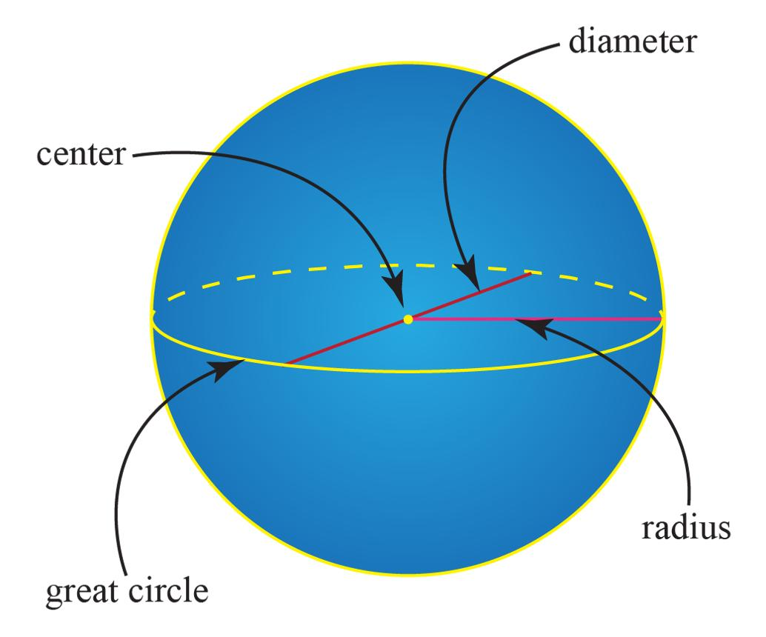
The main geometric components of a sphere are:
- Center ($O$): The fixed point at the middle of the sphere.
- Radius ($r$): The distance from the center to any point on the spherical surface.
- Diameter ($d$): A line segment through the center with both endpoints on the surface.
- Spherical surface: The curved boundary surrounding the solid sphere.
- Great circle: A circle formed by intersecting the sphere with a plane passing through its center.
- Hemisphere: One of the two halves formed when a plane passes through the center and divides the sphere into equal parts.
The diameter is twice the radius:
$$\boxed{d=2r}$$

Mathematical Representation and Formulas

A. Equation of a Sphere
# Source: AI Source: Provided by: [Data Path: Persons Table -> ID Column: 1, Name_En Column: Motasem Essam] -> From: [ChatGPT] on [7/25/2026]
For a sphere centered at the origin in three-dimensional Cartesian coordinates:
$$\boxed{x^{2}+y^{2}+z^{2}=r^{2}}$$
For a sphere centered at $\left(a,b,c\right)$:
$$\boxed{{\left(x-a\right)}^{2}+{\left(y-b\right)}^{2}+{\left(z-c\right)}^{2}=r^{2}}$$
These equations describe the spherical surface. To describe the entire solid sphere, replace the equality with $≤$.

B. Surface Area
# Source: AI Source: Provided by: [Data Path: Persons Table -> ID Column: 1, Name_En Column: Motasem Essam] -> From: [ChatGPT] on [7/25/2026]
The surface area of a sphere is:
$$\boxed{A=4πr^{2}}$$
Using the diameter $d=2r$, the formula can also be written as:
$$\boxed{A=πd^{2}}$$

C. Volume
# Source: AI Source: Provided by: [Data Path: Persons Table -> ID Column: 1, Name_En Column: Motasem Essam] -> From: [ChatGPT] on [7/25/2026]
The volume of a solid sphere is:
$$\boxed{V=\frac{4}{3}πr^{3}}$$
Using the diameter:
$$\boxed{V=\frac{πd^{3}}{6}}$$

D. Circumference of a Great Circle
# Source: AI Source: Provided by: [Data Path: Persons Table -> ID Column: 1, Name_En Column: Motasem Essam] -> From: [ChatGPT] on [7/25/2026]
A great circle has radius $r$, so its circumference is:
$$\boxed{C=2πr=πd}$$

E. Hemisphere Formulas
# Source: AI Source: Provided by: [Data Path: Persons Table -> ID Column: 1, Name_En Column: Motasem Essam] -> From: [ChatGPT] on [7/25/2026]
A hemisphere is half of a sphere.
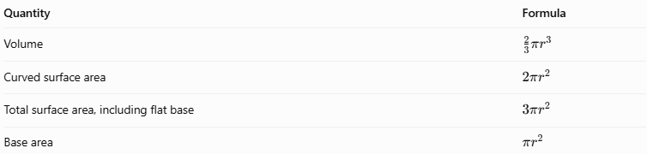
Quantity | Formula
Volume | $$\frac{2}{3}πr^{3}$$
Curved surface area | $$2πr^{2}$$
Total surface area, including flat base | $$3πr^{2}$$
Base area | $$πr^{2}$$

Worked Examples
# Source: AI Source: Provided by: [Data Path: Persons Table -> ID Column: 1, Name_En Column: Motasem Essam] -> From: [ChatGPT] on [7/25/2026]
Example 1: Calculating the Surface Area
A sphere has a radius of $5\text{ cm}$. Find its surface area.
Step 1 — Write the formula.
$$A=4πr^{2}$$
Step 2 — Substitute the radius.
$$A=4π{\left(5\right)}^{2}=100π$$
Answer:
$$\boxed{A≈314.16{\text{ cm}}^{2}}$$
Example 2: Calculating the Volume
A sphere has a diameter of $12\text{ cm}$. Find its volume.
Step 1 — Find the radius.
$$r=\frac{d}{2}=\frac{12}{2}=6\text{ cm}$$
Step 2 — Apply the volume formula.
$$V=\frac{4}{3}π{\left(6\right)}^{3}$$
$$V=288π$$
Answer:
$$\boxed{V≈904.78{\text{ cm}}^{3}}$$
Example 3: Finding the Radius from the Surface Area
A sphere has a surface area of $196π{\text{ cm}}^{2}$. Find its radius.
Step 1 — Start with the formula.
$$4πr^{2}=196π$$
Step 2 — Divide both sides by $4π$.
$$r^{2}=49$$
Step 3 — Take the positive square root.
$$\boxed{r=7\text{ cm}}$$
Example 4: Finding the Radius from the Volume
A sphere has a volume of $288π{\text{ cm}}^{3}$. Find its radius.
$$\frac{4}{3}{πr}^{3}=288π$$
Dividing both sides by $\frac{43}{π}$:
$$r^{3}=216$$
Taking the cube root:
$$\boxed{r=6\text{ cm}}$$

Constructing a Sphere

Geometric Instruments
# Source: AI Source: Provided by: [Data Path: Persons Table -> ID Column: 1, Name_En Column: Motasem Essam] -> From: [ChatGPT] on [7/25/2026]
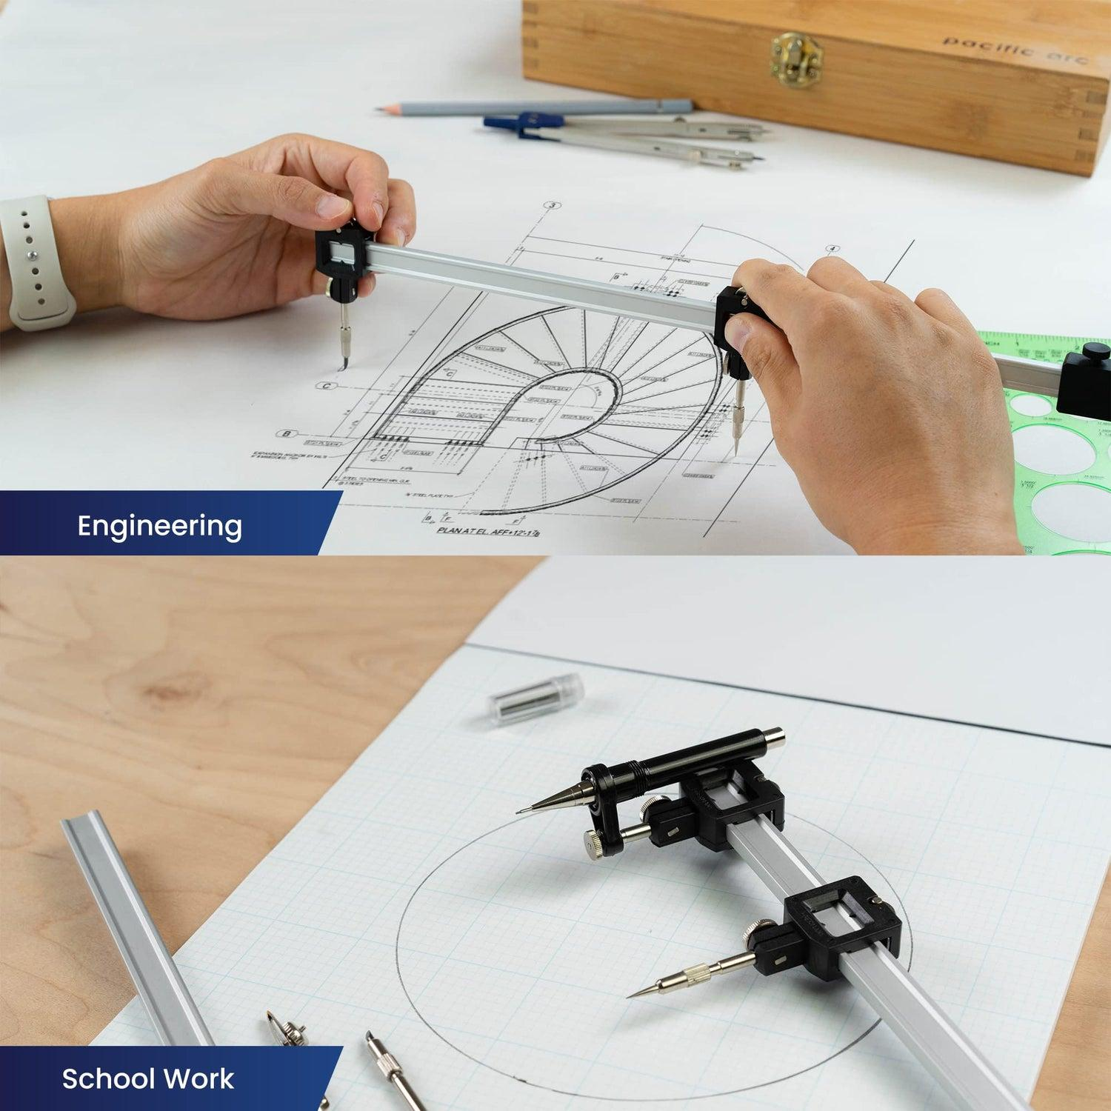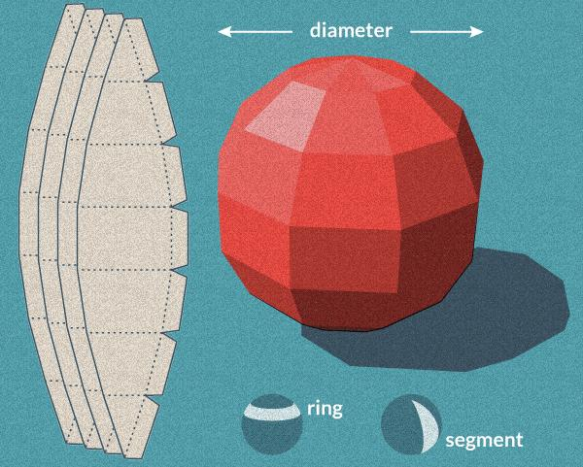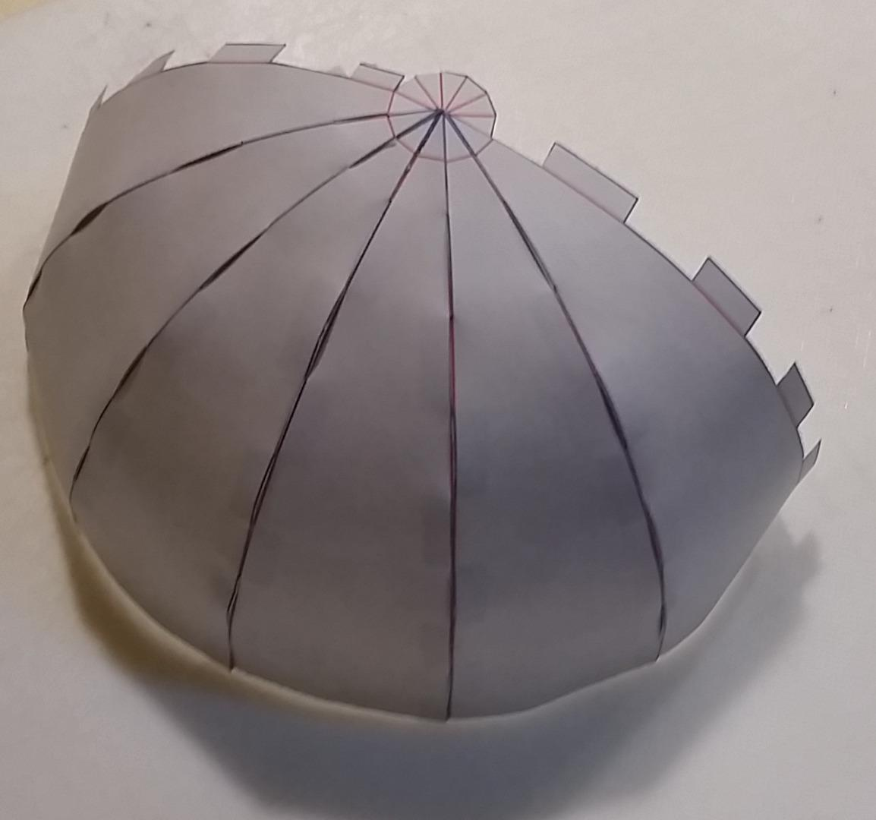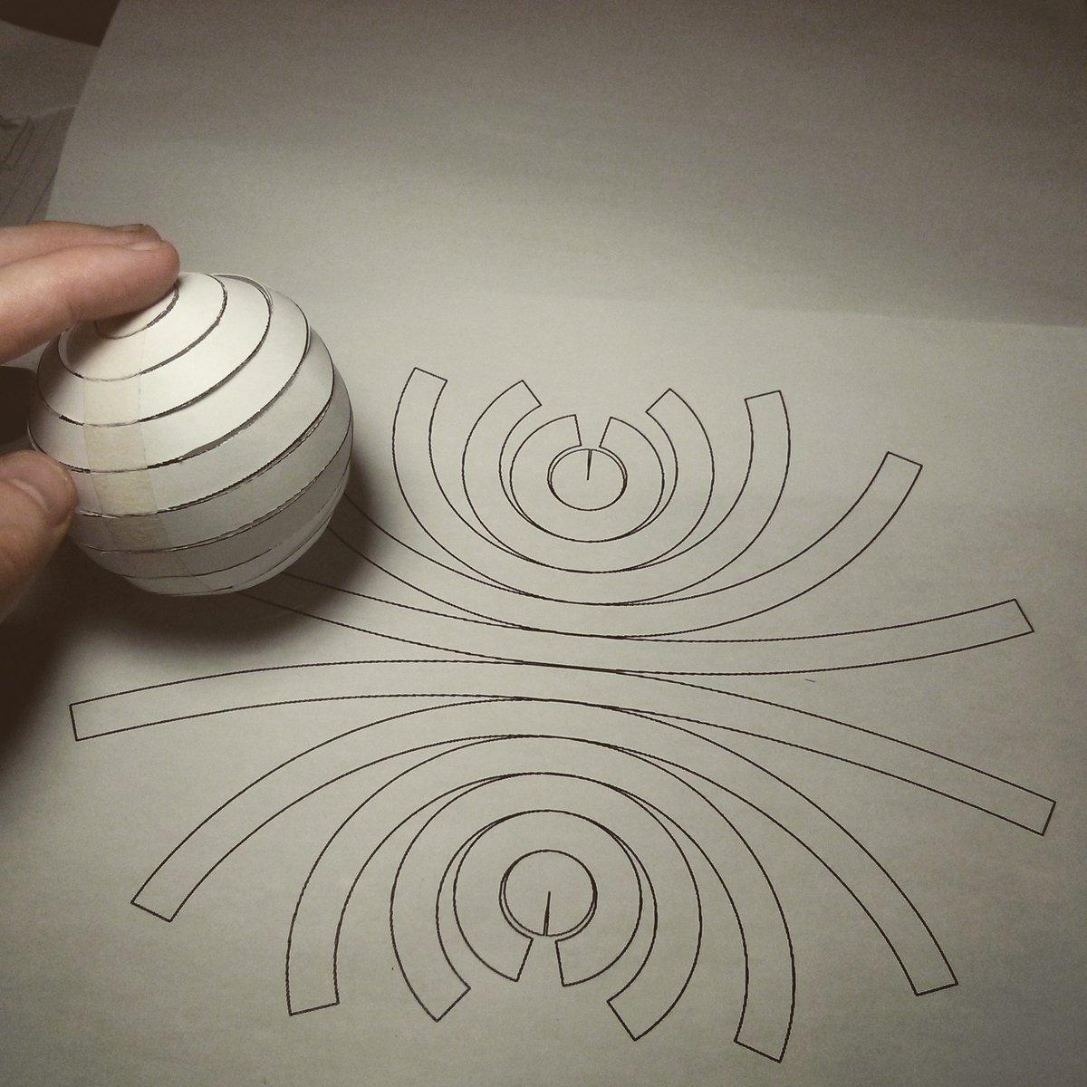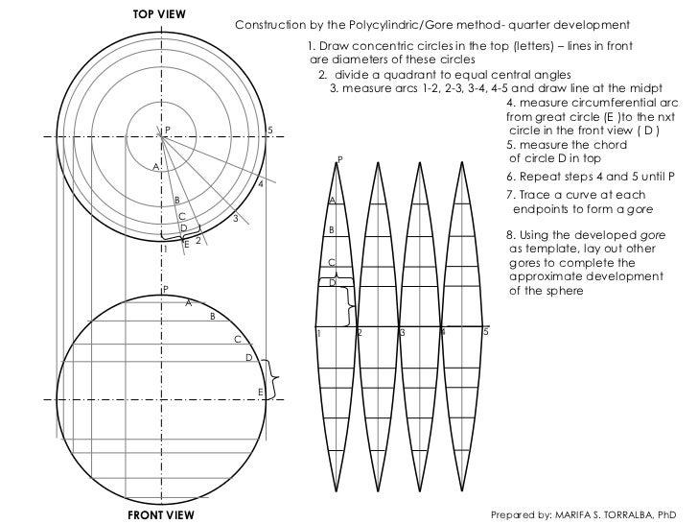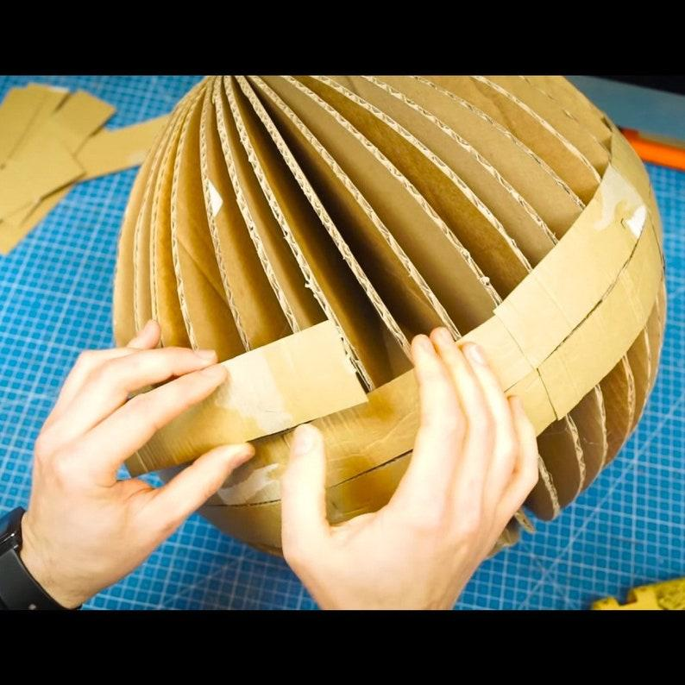
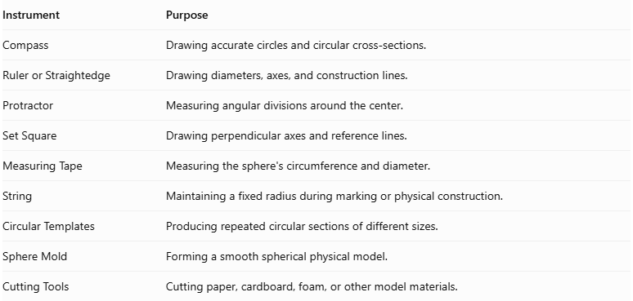
Instrument | Purpose
Compass | Drawing accurate circles and circular cross-sections.
Ruler or Straightedge | Drawing diameters, axes, and construction lines.
Protractor | Measuring angular divisions around the center.
Set Square | Drawing perpendicular axes and reference lines.
Measuring Tape | Measuring the sphere's circumference and diameter.
String | Maintaining a fixed radius during marking or physical construction.
Circular Templates | Producing repeated circular sections of different sizes.
Sphere Mold | Forming a smooth spherical physical model.
Cutting Tools | Cutting paper, cardboard, foam, or other model materials.

Instrument-Based Construction Procedures

Method 1: Constructing a Sphere Using Circular Cross-Sections
# Source: AI Source: Provided by: [Data Path: Persons Table -> ID Column: 1, Name_En Column: Motasem Essam] -> From: [ChatGPT] on [7/25/2026]
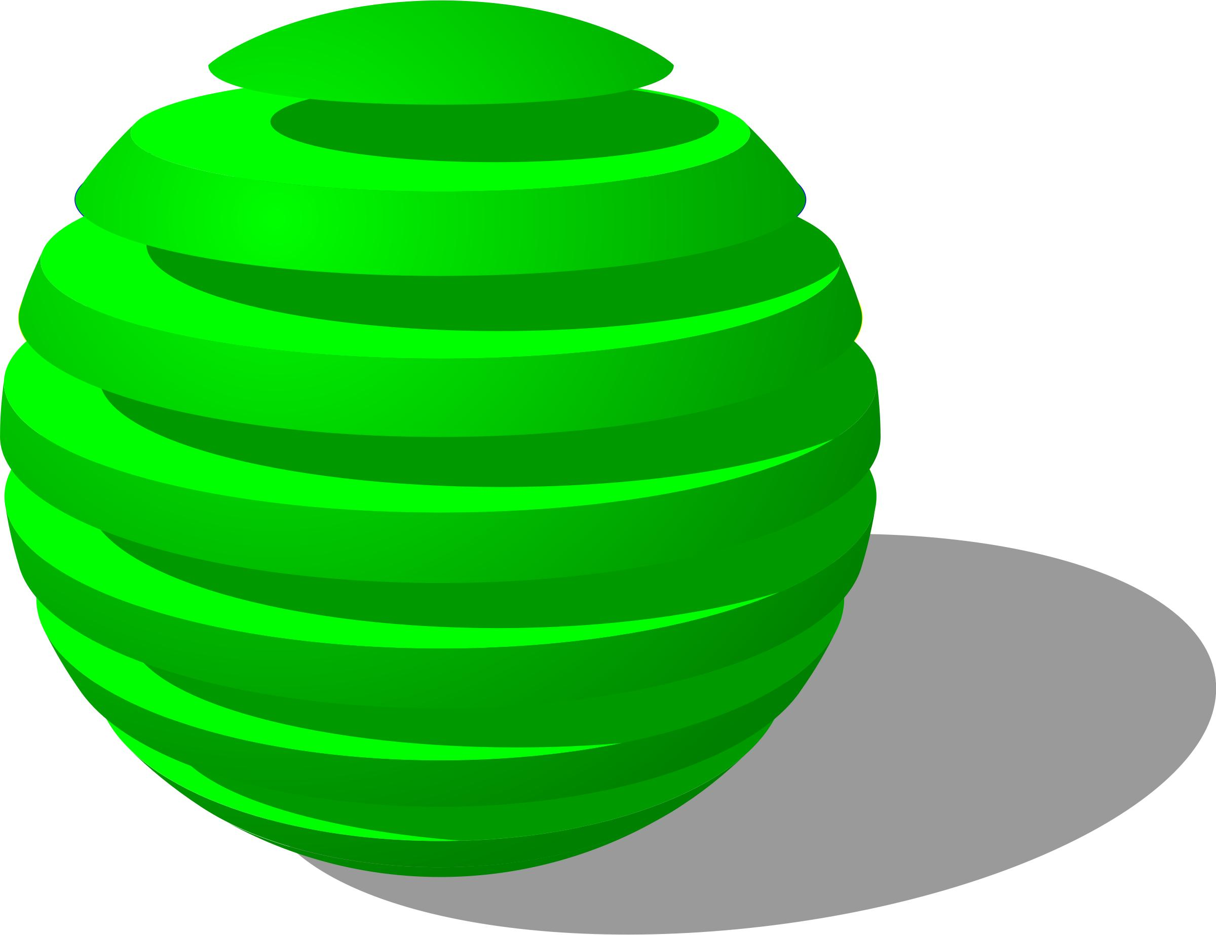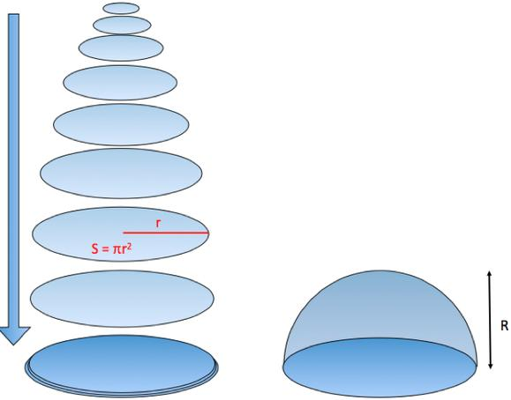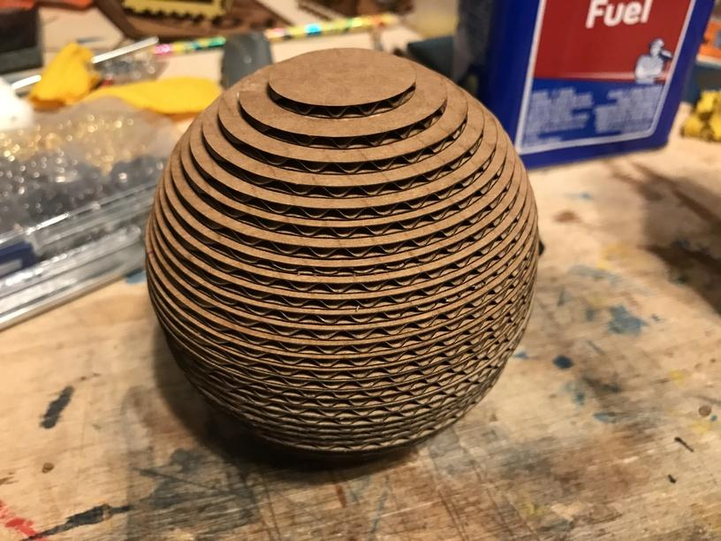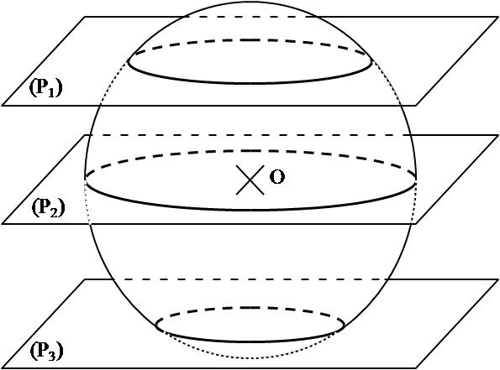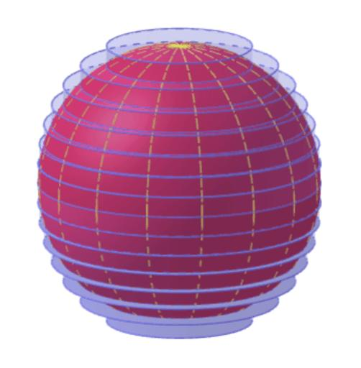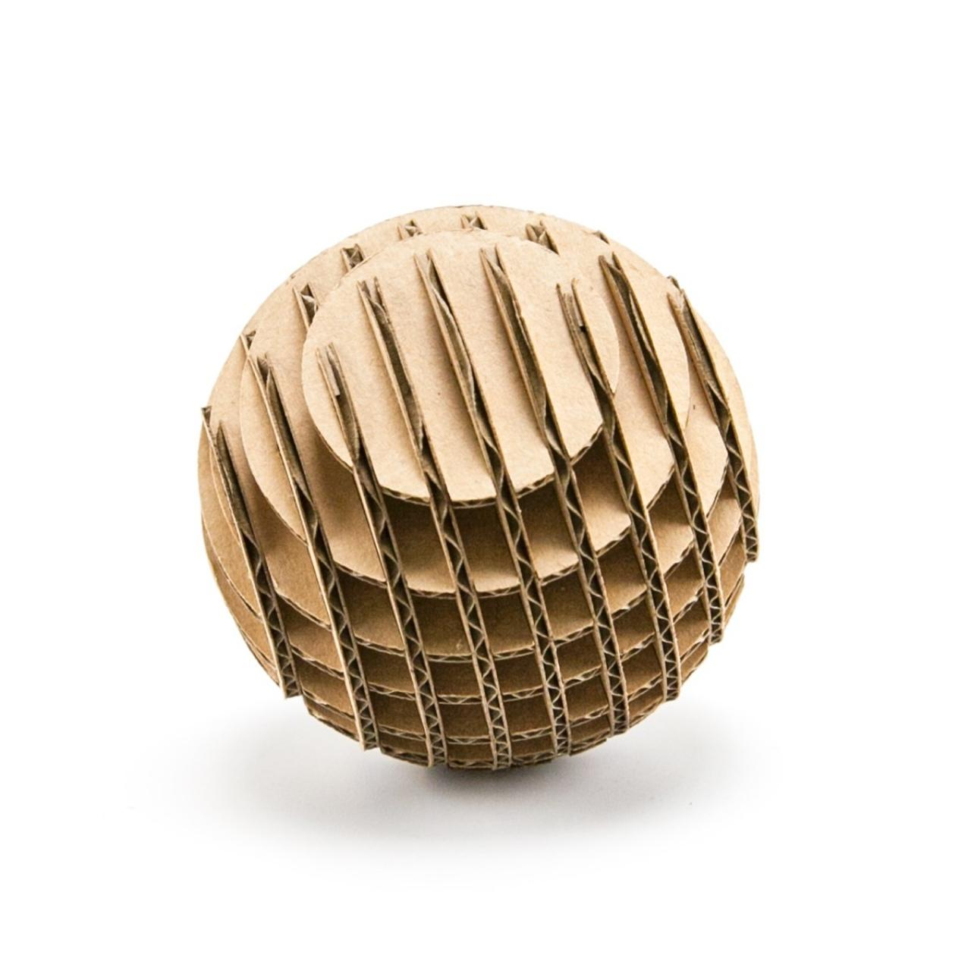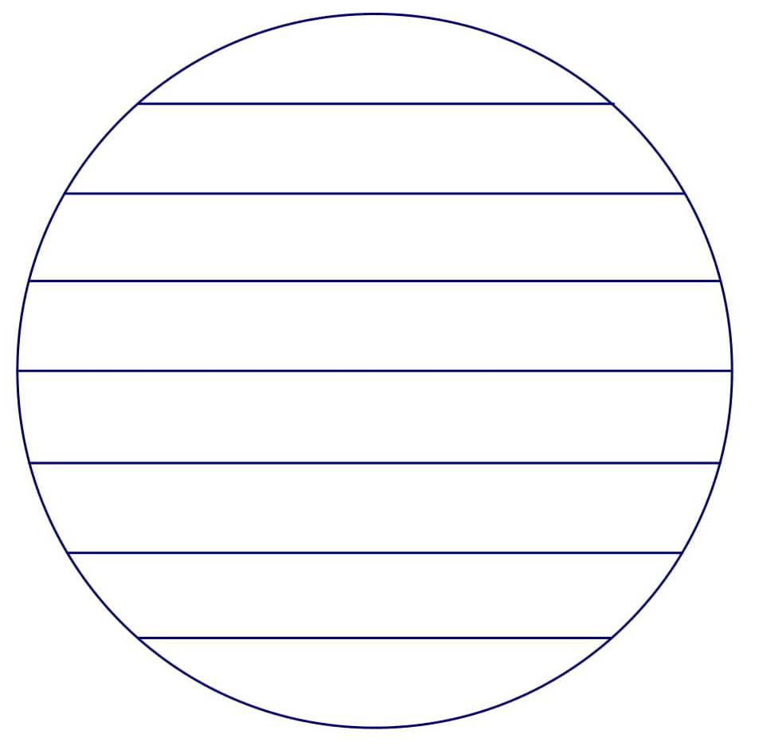
- Select the required sphere radius $r$.
- Mark the center of the intended sphere.
- Draw a vertical reference axis through the center.
- Divide the sphere's height into equally spaced horizontal levels.
- Determine the radius of each circular cross-section using geometric measurements.
- Draw the corresponding circles using a compass or circular templates.
- Cut the circles from cardboard, foam, or another suitable material.
- Arrange the circular sections perpendicular to the central axis, from the largest middle section toward the smallest upper and lower sections.
- Align all section centers along the same axis.
- Join the sections and smooth their outer boundaries to approximate a continuous spherical surface.

Method 2: Constructing a Sphere Using Rotational Symmetry
# Source: AI Source: Provided by: [Data Path: Persons Table -> ID Column: 1, Name_En Column: Motasem Essam] -> From: [ChatGPT] on [7/25/2026]
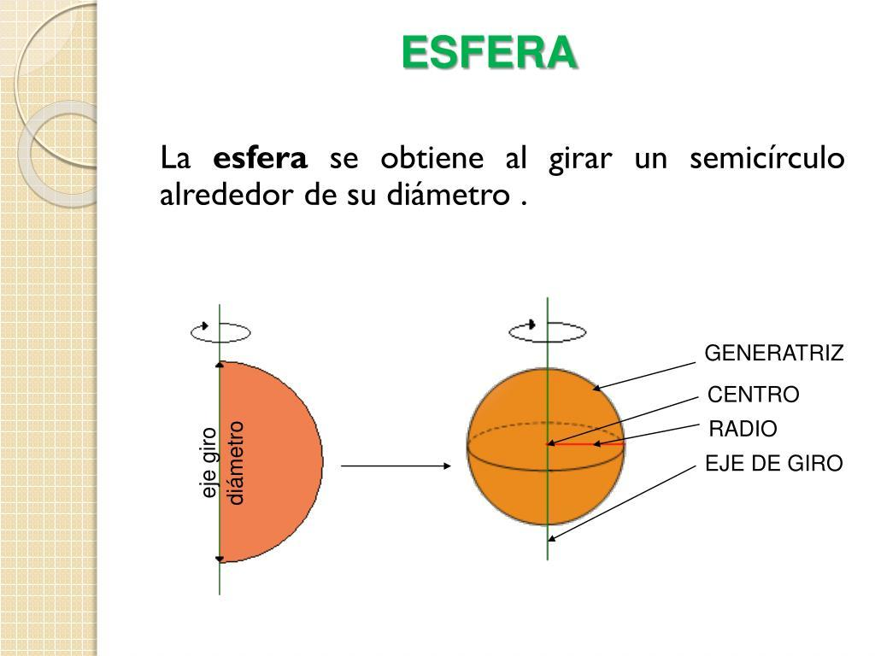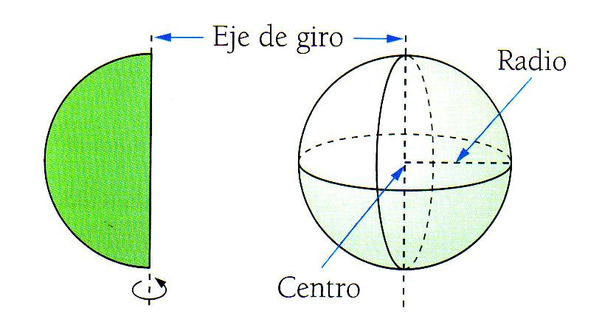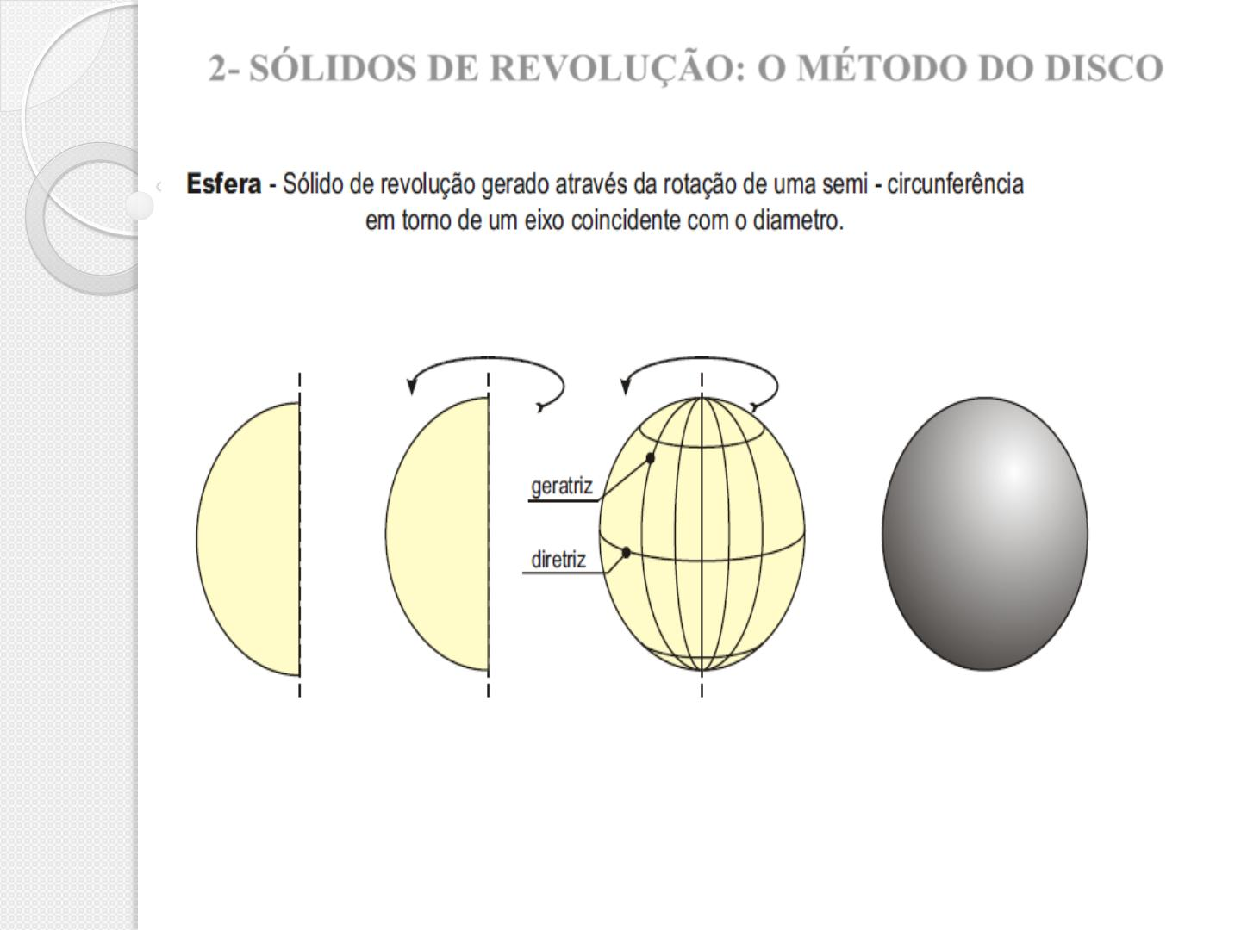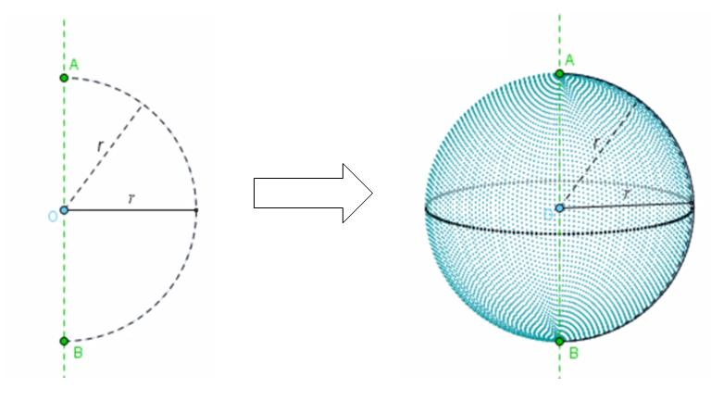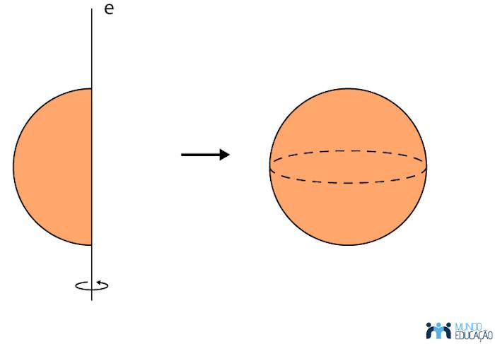
- Draw a straight line segment representing the sphere's diameter.
- Mark its midpoint as the sphere's center.
- Set the compass opening to half the diameter.
- Draw a semicircle using the diameter as its straight boundary.
- Treat the diameter as the axis of rotation.
- Construct or demonstrate a full ${360}^{°}$ rotation of the semicircle around this axis.
- The resulting three-dimensional surface represents a sphere.
Physical model option: Cut a semicircular profile from stiff material and rotate it around a fixed diameter axis using a suitable mechanical support or model-making apparatus.

Method 3: Constructing a Sphere Using Circular Templates
# Source: AI Source: Provided by: [Data Path: Persons Table -> ID Column: 1, Name_En Column: Motasem Essam] -> From: [ChatGPT] on [7/25/2026]
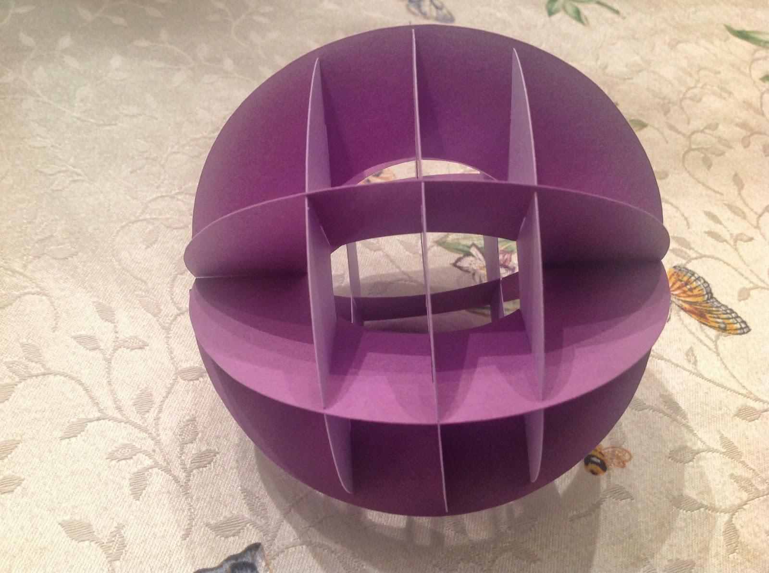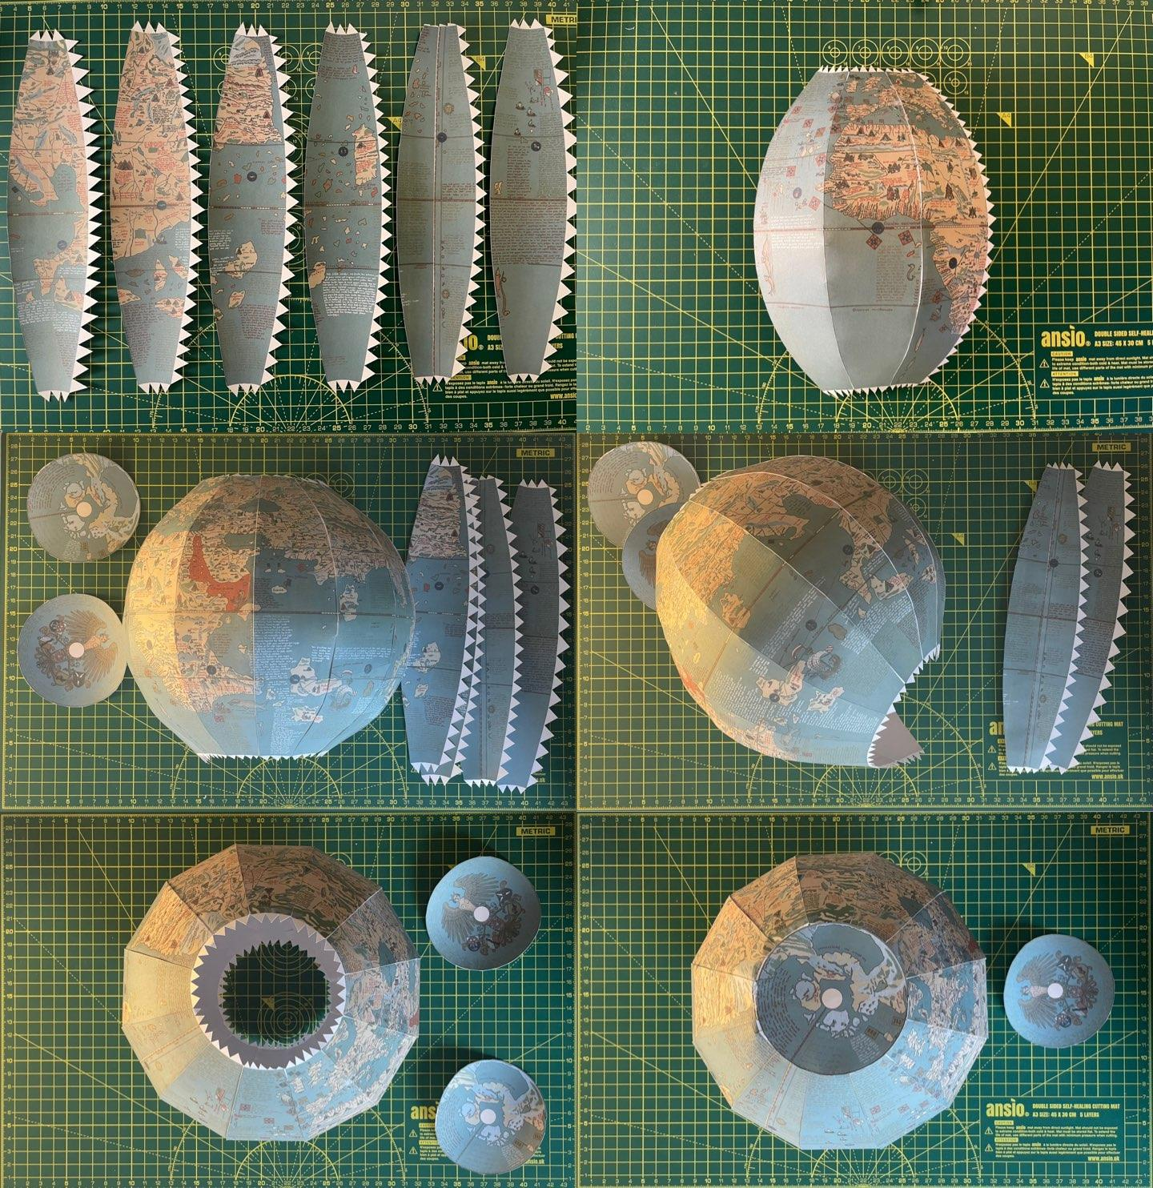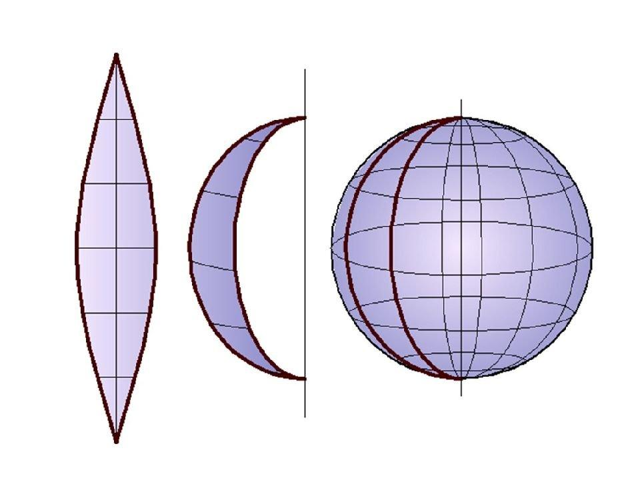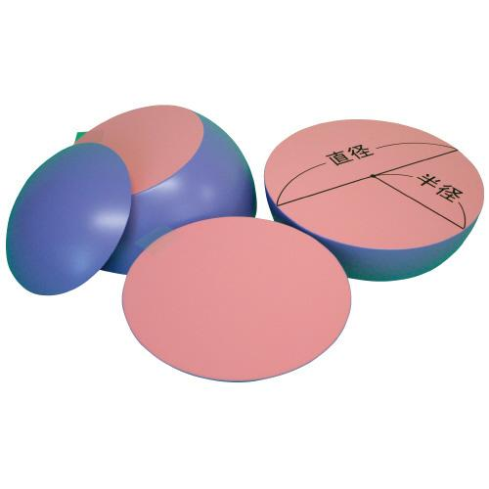
- Choose the sphere's radius and mark its center.
- Divide a vertical diameter into equal intervals.
- For each interval, determine the corresponding distance from the center.
- Calculate or geometrically measure the radius of the circular section at that level.
- Draw each circle using a compass.
- Cut the circular templates from suitable material.
- Arrange the sections symmetrically around the central axis.
- Join the sections and refine the outer surface.
This method produces a stepped approximation unless the sections are sufficiently numerous and the material is shaped smoothly.

Method 4: Constructing a Sphere Using a Mold
# Source: AI Source: Provided by: [Data Path: Persons Table -> ID Column: 1, Name_En Column: Motasem Essam] -> From: [ChatGPT] on [7/25/2026]
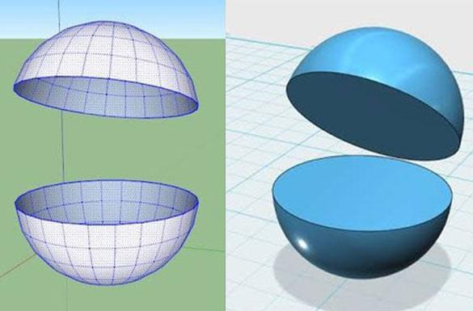
- Determine the required sphere radius.
- Prepare two identical hemispherical mold halves.
- Check that both halves have the same radius and matching circular rims.
- Align the two rims along the same circular boundary.
- Join the halves securely.
- Fill or shape the mold using a suitable modeling material.
- Remove the mold, if applicable, and smooth the surface.
- Verify the diameter and symmetry of the finished sphere.
This method is useful for producing a smooth physical sphere rather than a layered approximation.

Comparison with Related Geometric Shapes
# Source: AI Source: Provided by: [Data Path: Persons Table -> ID Column: 1, Name_En Column: Motasem Essam] -> From: [ChatGPT] on [7/25/2026]
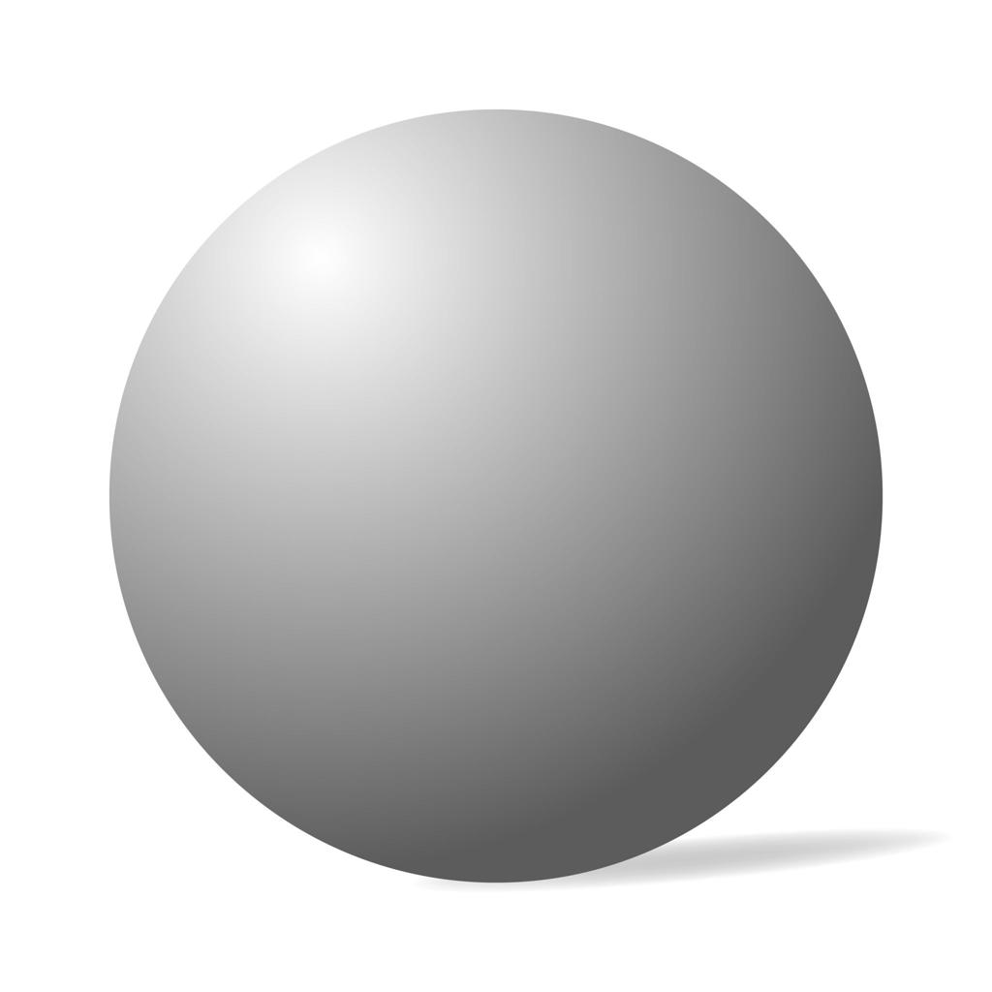
Sphere
A three-dimensional solid with a curved surface. It has volume and surface area but no flat faces, straight edges, or vertices.
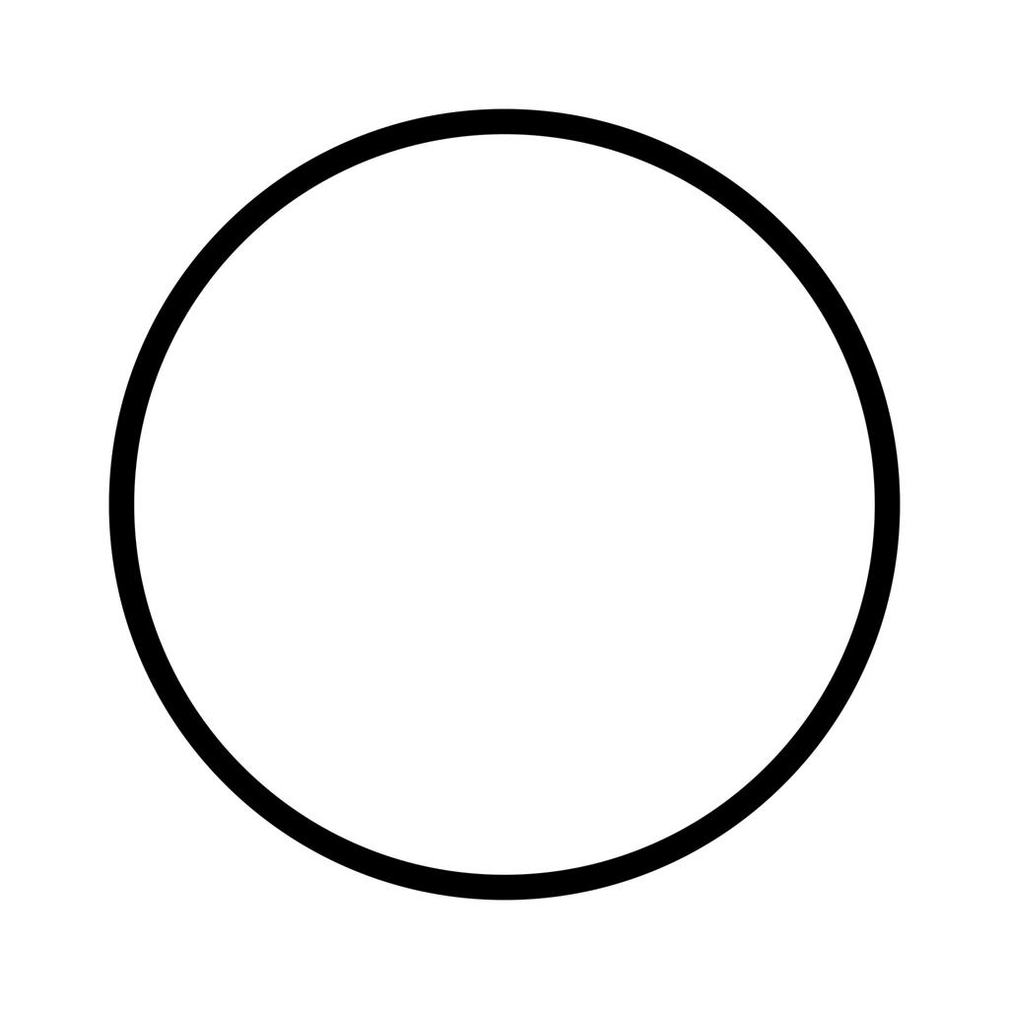
Circle
A two-dimensional figure consisting of a disk's interior and boundary in a plane. Its area is $πr^{2}$, and its circumference is $2πr$.
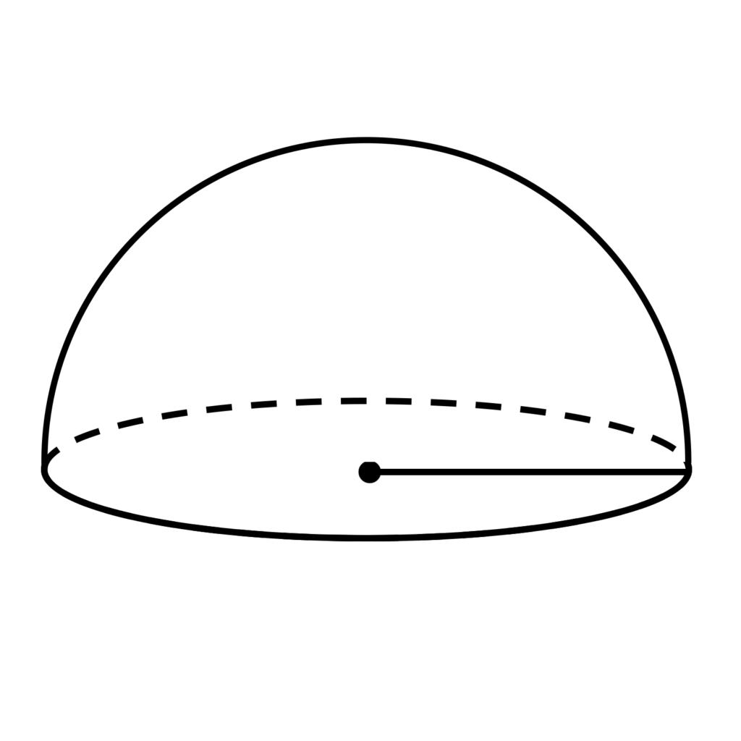
Hemisphere
Half of a solid sphere. It has one flat circular base and one curved surface.
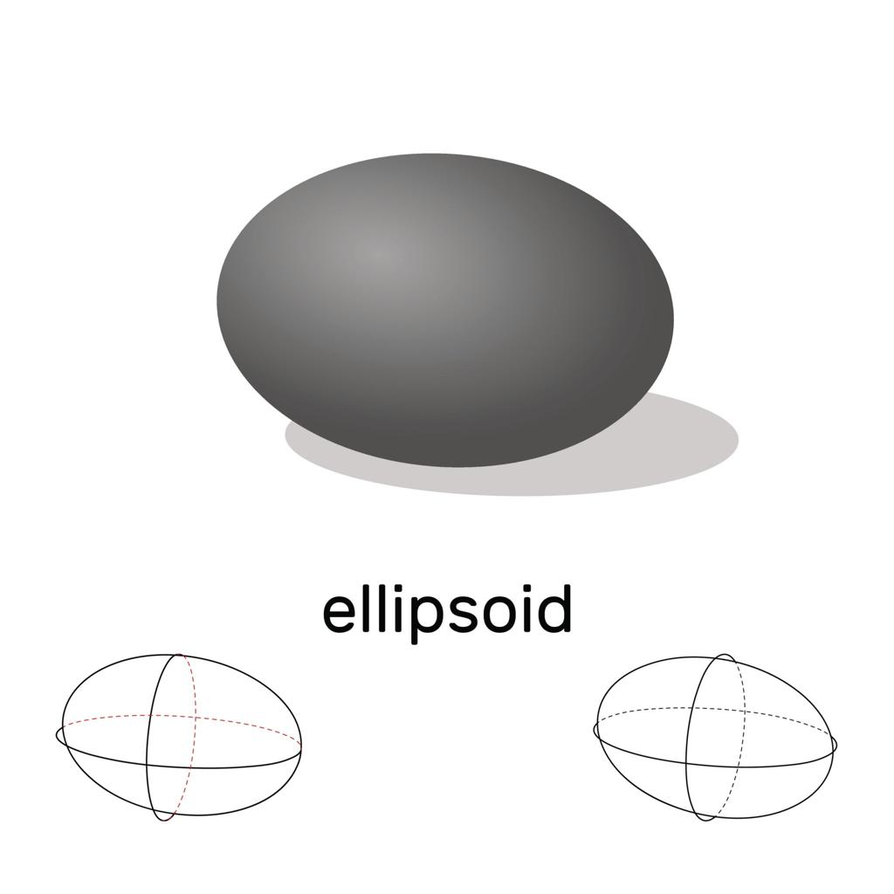
Ellipsoid
A rounded three-dimensional solid that may be stretched or compressed along its axes. Unlike a sphere, its surface points are not all the same distance from one center.

Applications of Spheres
# Source: AI Source: Provided by: [Data Path: Persons Table -> ID Column: 1, Name_En Column: Motasem Essam] -> From: [ChatGPT] on [7/25/2026]
- Astronomy: Modeling planets, stars, and other approximately spherical celestial bodies.
- Engineering: Designing spherical tanks, bearings, and ball joints.
- Architecture: Creating domes and spherical structures.
- Physics: Modeling objects and fields with spherical symmetry.
- Sports: Representing balls used in football, basketball, and other sports.
- Mathematics: Studying three-dimensional geometry, coordinates, distance, and symmetry.

Key Points
# Source: AI Source: Provided by: [Data Path: Persons Table -> ID Column: 1, Name_En Column: Motasem Essam] -> From: [ChatGPT] on [7/25/2026]
- A sphere is a three-dimensional solid bounded by a curved spherical surface.
- Every point on its surface is the same distance from its center.
- The diameter is twice the radius: $d=2r$.
- Its surface area is $A=4πr^{2}$.
- Its volume is $V=\frac{4}{3}πr^{3}$.
- A sphere has no flat faces, straight edges, or vertices.
- A great circle passes through the center of the sphere.
- A hemisphere is half of a sphere.
- The sphere's surface equation is $x^{2}+y^{2}+z^{2}=r^{2}$ when centered at the origin.

Conclusion
# Source: AI Source: Provided by: [Data Path: Persons Table -> ID Column: 1, Name_En Column: Motasem Essam] -> From: [ChatGPT] on [7/25/2026]
A sphere is a fundamental solid in geometry, distinguished by its perfectly round shape and uniform radius. Its surface area and volume depend only on its radius, making it one of the simplest curved solids to study mathematically. Spheres are important in geometry, physics, engineering, astronomy, and everyday objects.

